SOURCE CODE:
import random
import string
print ("Welcome to Password Generator!")
n_letters = int (input ("How many letters do you want? "))
n_numbers = int (input ("How many numbers do you want? "))
n_symbols = int (input ("How many symbols do you want? "))
password_list = []
for _ in range(n_letters):
password_list. append (random. Choice (string. ascii_letters))
for _ in range(n_numbers):
password_list. append (random. Choice (string. Digits))
for _ in range(n_symbols):
password_list. append (random. Choice (“! @#$%^&*()_+"))
random. Shuffle(password_list)
password = "“. join(password_list)
print ("Generated Password:", password)

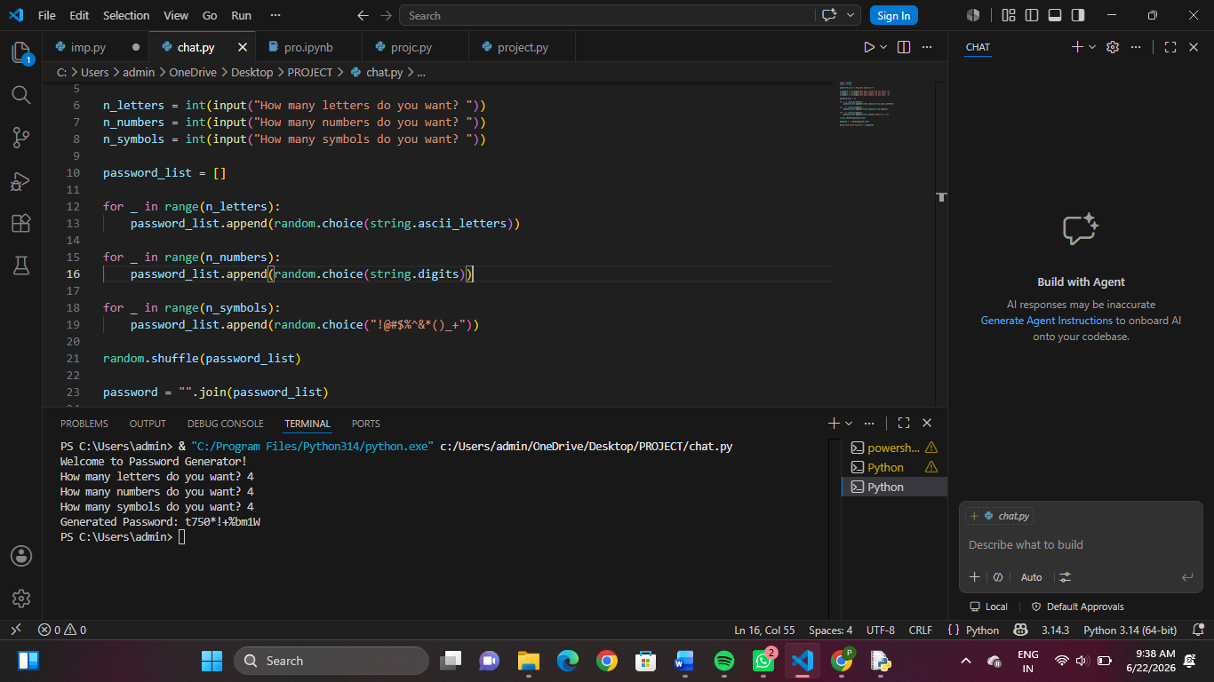
Fig: Output
